**Make every day human rights day**

Rights areas:

* [Support for human rights systems and defenders](https://fra.europa.eu/en/taxonomy/term/989)
* [Civil society](https://fra.europa.eu/en/taxonomy/term/993)
* [EU Charter of Fundamental Rights](https://fra.europa.eu/en/taxonomy/term/990)
* [Inter-governmental human rights systems](https://fra.europa.eu/en/taxonomy/term/991)

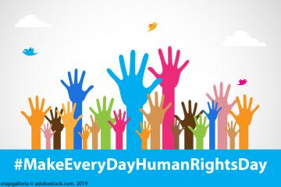

Today marks human rights day, a day that celebrates the Universal Declaration of Human Rights and what it means to all of us. But it should be a cause for celebration every day.

* + [WATCH VIDEO ON 10 YEARS OF THE EU CHARTER](https://fra.europa.eu/en/video/2019/celebrating-10-years-eu-charter-fundamental-rights)
  + [WATCH COMMUNICATING RIGHTS VIDEO](https://fra.europa.eu/en/video/2019/10-keys-effectively-communicating-human-rights)

The Declaration is the cornerstone of international human rights law. This landmark document sets out the rights that everyone is entitled to, no matter who they are, whatever their differences. In essence, everyone is born free and equal in dignity and rights.

Looking back, it took human rights from national arenas to the international stage. It also inspired the EU’s very own bill of fundamental rights and freedoms – the Charter of Fundamental Rights. This year, the Charter also celebrates 10 years of being a legal *tour de force*.

The Declaration also helped shape the nine core international human rights treaties that govern issues from children to disability, from civil and political rights to economic to social and cultural rights.

It, together with the treaties and the EU Charter, created better access to justice, social protection, economic opportunities and political participation for millions of people across the EU.

Today, all UN Member States subscribe to the Declaration. But even so, governments within and beyond the EU, often sidestep or roll back on their human rights commitments, undermining many decades of progress.

Racism, discrimination and intolerance are common in many societies within the EU, as [many FRA surveys show](https://fra.europa.eu/en/publications-and-resources/data-and-maps?mdq1=theme).

Attacks on free speech continue and civil society face a range of difficulties trying to advance rights, as [FRA work shows](https://fra.europa.eu/en/publication/2018/challenges-facing-civil-society-orgs-human-rights-eu). These include threats, legal restrictions and being crowded out of policy discussions.

To deliver our rights, we need to apply the Charter. That’s why we need to stand up for our rights and those of others.

We must pass on the message that equality, justice and freedom empower us all, prevent violence and sustain peace.

That message should not be just for human rights day. In that sense, we should ensure that we make every day, human rights day.